URL: https://pavconstructionllc.com/location/dennis/custom-home-building

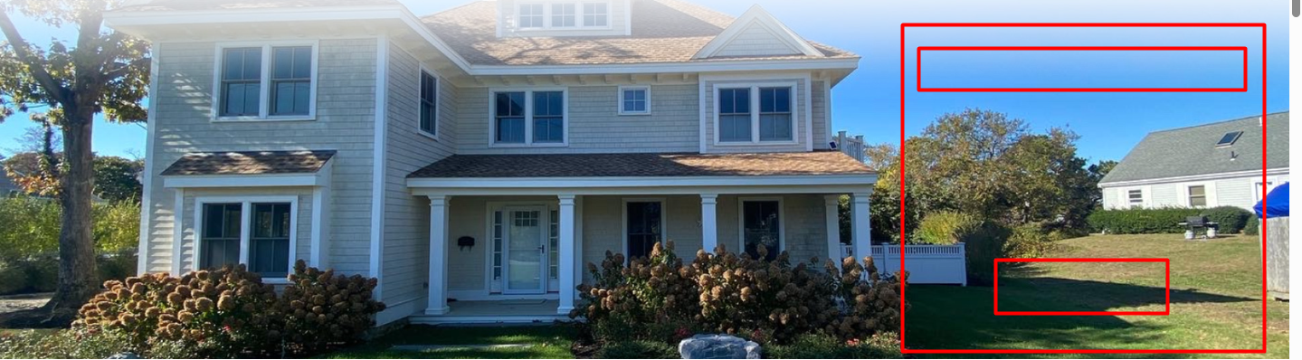

Custom Home Builder in Dennis, MA — Page Copy Draft

1. Hero Section
H1: Custom Home Builder in Dennis, MA
Subhead: Building elegant, coastal-ready custom homes across East Dennis, South Dennis, West Dennis, and Dennisport — with the craftsmanship and local knowledge Cape Cod living demands.
CTA Button: Start Your Custom Home → links to consultation form. Secondary CTA (phone): Call (508)-367-9733

2. Why Build in Dennis / Local Intro
H2: Building Your Dream Home in Dennis, Massachusetts
Dennis sits at the heart of Cape Cod, stretching from the shores of Cape Cod Bay to Nantucket Sound — home to five distinct villages, each with its own character, from the historic charm of Dennis Village to the beachside energy of West Dennis and Dennisport.
Building here isn't the same as building anywhere else. Coastal exposure, salt air, older lot patterns, and Dennis's own permitting process all shape how a custom home should be designed and built. Pav Construction has spent [15+] years building on Cape Cod, and we bring that experience to every custom home we build in Dennis — from first sketch to final walkthrough.
Inline CTA: Ready to talk through your Dennis property? [Schedule a Free Consultation →]

3. Who Is Pav Construction
H2: Meet Your Dennis Custom Home Builder
Pav Construction LLC is a family-owned, design-build firm based in Chatham, MA, specializing in luxury custom homes, additions, and full-scale renovations throughout Cape Cod. With [50+] years of combined building experience on our team, we handle your project from initial design and permitting through final construction — all under one roof, with one dedicated project manager keeping things on track.
We're not a franchise or an out-of-town crew. We're licensed, insured, and invested in this community — supporting local organizations like the Rotary Club, D/Y Youth Lacrosse, and Bridgeview Montessori School.
CTA: Meet the Full Team → (https://pavconstructionllc.com/about-us/#meet-our-team)

4. Why Choose Pav Construction for Your Dennis Custom Home
H2: Why Homeowners in Dennis Choose Pav Construction
- Deep experience building on Cape Cod's coastal lots — cedar shingle siding, storm-rated roofing, and materials that hold up to salt air
- Complete design-build services under one roof — no juggling separate architects and contractors
- We manage all Dennis building and construction permits, including coastal and conservation-related requirements
- Fully dedicated project manager assigned to your home from day one
- Transparent, itemized pricing — no surprise change orders
- Custom cabinetry and built-ins designed around how you actually live
- Fully licensed and insured, with a warranty on our craftsmanship
- Local, family-owned — we answer the phone, and we live where we build
CTA: Get Your Free Estimate → Contact us

5. Local Building & Permitting Knowledge
H2: We Know What It Takes to Build in Dennis
Dennis has its own building department, Conservation Commission, and Board of Health — each with requirements that can shape your project timeline if they're not planned for early.
- Coastal & wetlands review: Properties near Sesuit Harbor, Bass River, or the bayside marshes often require Conservation Commission review before construction can begin.
- Historic districts: Homes along Route 6A or in designated historic areas may need design approval to preserve the look of the neighborhood.
- Septic & Title 5: Older lots frequently require septic system upgrades when adding bedrooms or expanding square footage.
- Coastal flood zones: Bay-front and sound-front lots come with additional building code and elevation considerations.
We fold all of this into your project from the very first conversation — so it shapes your design instead of stalling your schedule.

6. Our Custom Home Building Process
H2: From First Conversation to Final Walkthrough
- Consultation — We talk through your goals, your Dennis property, and your budget.
- Design — Our design team creates a home that fits your vision and the character of the neighborhood.
- Permitting — We handle every filing, from the building department to Conservation Commission, if needed.
- Construction — Your dedicated project manager keeps the build on schedule and on budget.
- Final Walkthrough — We walk your finished home with you, start to finish, until every detail is right.
CTA: See What to Expect → (https://pavconstructionllc.com/what-to-expect/)

7. Featured Dennis Projects
H2: Recent Work in Dennis & the Mid-Cape
[Insert 2–3 real project photos + one-line descriptions here, e.g.:]
- East Dennis Shingle-Style Custom Home — A ground-up build blending classic Cape Cod exterior with an open, modern interior layout.
- West Dennis Waterfront Remodel — Full renovation preserving the home's original character while adding coastal-resilient materials.
- South Dennis Addition — A seamless addition that expanded living space without disrupting the home's historic front façade.
CTA: View Our Full Project Gallery → (https://pavconstructionllc.com/case-studies/)

8. Architectural Styles We Build in Dennis
H2: Styles That Fit Dennis's Coastal Character
- Cape Cod Cottage — steep roofs, dormers, central chimney, modest footprint
- Shingle Style — wraparound porches, weathered cedar, flowing coastal forms
- Colonial Revival — symmetrical façades with classic New England detail
- Contemporary & Transitional — large windows, open floor plans, energy-efficient systems built for indoor-outdoor living

9. What Dennis Homeowners Say
H2: Hear From Our Clients
"Pav tore down the old house, preserving then adding to the foundation, helped us design and then build a new custom home. He and his team did top quality work and got things done on time. His design suggestions were excellent, his subs were excellent." — Jeffery Weilburg
"Pav rebuilt our home from the ground up and came in on budget and on time. His architect was fast, efficient and on target and his terrific project manager ensures that there is no drama." — Diane Holland

10. Frequently Asked Questions
H2: Custom Home Building in Dennis — FAQ
How long does it take to build a custom home on Cape Cod? Timelines vary by size, design complexity, and permitting, but most custom homes take [12–18 months] from initial design through move-in. We'll give you a project-specific timeline during your consultation.
Do I need Conservation Commission approval to build in Dennis? It depends on your lot. Properties near wetlands, Sesuit Harbor, or the Bass River corridor often require review. We assess this early in the process so it doesn't delay your build.
What does it cost to build a custom home in Dennis, MA? Costs depend on size, finishes, and site conditions. We provide transparent, itemized pricing during your consultation so there are no surprises later.
Do you handle the permitting process? Yes — we manage all necessary building and construction permits, including any Conservation Commission or historic district requirements.
Can you build in any of the Dennis villages? Yes. We build across East Dennis, South Dennis, West Dennis, North Dennis, and Dennisport.
CTA: Have a question we didn't answer? [Contact us directly →]

11. Areas We Serve in Dennis
H2: Serving All of Dennis
East Dennis · South Dennis · West Dennis · North Dennis · Dennisport
(Consider linking each village name to a short dedicated section or anchor if you build out village-level content later.)

12. Final CTA Section
H2: Ready to Build Your Custom Home in Dennis?
We'd love to hear about your vision. Fill out the form below for a complimentary consultation, and our team will be in touch by the next business day.
CTA Button: Request Your Free Consultation Form fields: Name / Email / Phone / Message (optional) Phone CTA: (508)-367-9733

